# **Tasks (YASH AGARWAL)**

**Objective Questions**:

1. **What is the total no. of attributes present in the data?**

**Tickets Sheet:**

This sheet contains detailed information about each IT support ticket raised by employees.

**Attributes:**

· ID (Unique identifier for the ticket)

· Ticket Fecha (Date of the ticket)

· Employee ID (ID of the employee who raised the ticket)

· Agent ID (ID of the agent assigned to the ticket)

· Request Category (Category of the request, e.g., Login Access, System Software)

· Issue Type (Type of issue, e.g., IT Error, IT Request)

· Severity (Severity of the issue)

· Priority (Priority level of the issue)

· Resolution Time (Days) (Time taken to resolve the ticket)

· Satisfaction Rate (Satisfaction rate provided by the employee on a 1-5 scale)

**Total Attributes in Tickets Sheet: 10 attributes**

**IT Agents Sheet:**

This sheet contains information about the IT agents.

**Attributes:**

· Agent ID (Unique identifier for the agent)

· Full Name (Full name of the agent)

· Email (Email address of the agent)

· Year of Birth (Year the agent was born)

· Month of Birth (Month the agent was born)

· Day of Birth (Day the agent was born)

**Total Attributes in IT Agents Sheet: 6 Attributes**

**Total Attributes Present in both the Sheets: 16**

1. **Which columns have inconsistent or missing values, and what is the count of such values?**

**cc**

**Column Severity**:

Contains Spelling Error:

Unclasified 🡪 unclassified (Count: 356)

Mayor 🡪 Major (Count: 4836)

**Column Priority:**

Contains Spelling Error:

Unassiged 🡪 Unassigned (Count: 29410)

Correction in Spellings are made through:

Check Spelling Option under Review Ribbon in Excel.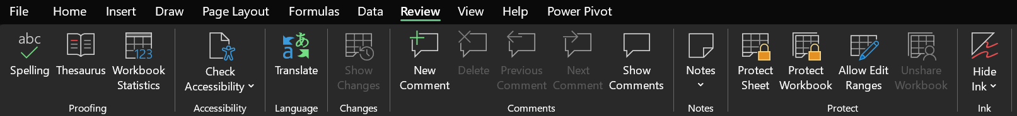

1. **What is the average daily ticket volume over time?**

The average daily ticket volume provides insights into how many tickets are typically raised each day. This helps evaluate the workload and resource allocation for IT agents.

**Calculation:**

Formula: Average Daily Ticket Volume = Total Tickets / Total Days

Total Tickets: 97,498 (calculated using the COUNT function on the Ticket IDs column).

Total Days: 1,827 (calculated using count and unique function on fecha column).

Average Daily Ticket Volume = 97,498 / 1,827 ≈ 53.36508

1. **What is the distribution of ticket categories (e.g., Login Access, System, Software)?**

Tickets are Distributed as below:

· **Highest Ticket Volume**: The "System" category has the highest ticket volume, contributing to 40% of the total tickets (39,002 out of 97,498).

**· Lowest Ticket Volume**: The "Hardware" category has the lowest ticket volume, contributing to 10% of the total tickets (9,733 out of 97,498).

· **Login Access and Software**: Together, these categories make up approximately 52% of the total tickets.

1. **How many tickets has each agent handled?**

**Data Reference: Refer to Table 1 in Sheet Pivot**

Some of the results are shown below

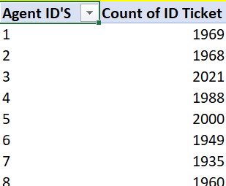

1. **How can you extract the domain from the email addresses in the IT Agents sheet?**

The Excel Formula for extracting domain name from email Id is

**=MID (C2, FIND ("@”, C2,1) +1, FIND (“.”, C2, FIND ("@", C2,1))-FIND ("@", C2,1)-1)**

Email Domains are extracted as **Domain Column** in **Sheet IT Agents**

1. **How can you find the full name of an agent given their Agent ID?**

VLOOKUP () function is used to find the Full Name of the Agents.

The Excel Formula for extracting Full name of Agent through Agent ID is

**=VLOOKUP (D2,'IT Agents’! $A$1: $B$51,2,0)**

Were,

**D2** 🡪 Agent’s ID

**'IT Agents’! $A$1: $B$51**🡪Range from name is found

**2** 🡪 Index number (Column Number) in the range which is needed to be returned i.e. Full Name of Agent

**0🡪** Exact Match type(0/FALSE)

1. **What is the count of each issue type (e.g., IT Error, IT Request)?**

Count for each issue type is depicted in the table below:

1. **What is the daily average resolution time for tickets?**

For calculating the daily average resolution time for tickets , A pivot table is created where fecha values are taken in to rows with categorising them into month🡪Quarter🡪Year and average of resolution is taken as values.

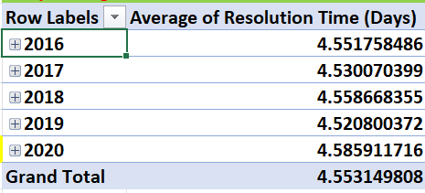

**Therefore, Daily Average Resolution time for tickets Over the time is 🡪4.55**

1. **How has the volume of tickets changed over time?**

An Increase in Volume of tickets is seen over time:

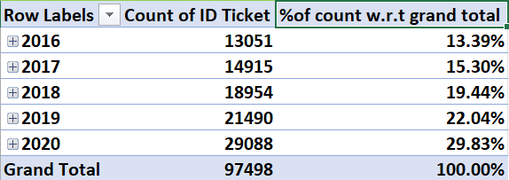

1. **What is the average age of the IT agents?**

The Average Age of IT Agents is 🡪 **39.88**

For calculating the average age of Agents Average function is used.

The formulae used is 🡪 =AVERAGE ('IT Agent’! H2:H51)

1. **Is there a correlation between the severity of issues and the resolution time?**

The Correlation between the Severity of Issue and Resolution Time is founded by using 🡪 Data Analysis option under Data Ribbon

If,

Value Close to 🡪 0(Zero) 🡪 NO CORRELATION

Value Close to 🡪1 (One) 🡪 CORRELATED

Demonstration is been Shown below:

As we can see Correlation value(r) for SEVERITY OF ISSUE & RESOLUTION TIME is **-0.405** (close to zero (0)) - NEGATIVE

Therefore, **NOT CORRELATED**

1. **How many categorical columns are there in the data? [Search about categorical and continuous data, and try to answer this question]**

The dataset comprises 12 categorical columns and 3 continuous columns. Below is the detailed classification of each column:

**Categorical Columns:**

* ID Ticket
* Fecha
* Employee ID
* Agent ID
* Request Category
* Issue Type
* Severity
* Priority
* Full Name
* Email
* Month of Birth

**Continuous Columns:**

* Resolution Time (Days)
* Satisfaction Rate
* Year of Birth

**TOTAL COUNT:**

**CATEGORICAL COLUMNS🡪 12**

**CONTINUOUS COLUMNS🡪3**

**Subjective Question:**

1. **If there is an investment, should it be used to hire more IT agents, improve training programs, or upgrade ticket management software?**

**Analysis: Perform a cost-benefit analysis using ticket resolution and satisfaction metrics.**

To determine whether to invest in Hiring more IT agents, improving training programs, or Upgrading ticket management software, a cost-benefit analysis was conducted based on key metrics like ticket resolution time and satisfaction rate. Data from the "Analysis" sheet indicates an average satisfaction rate of 4.101 and an average resolution time of 4.55 days.

These figures suggest room for improvement, especially in reducing resolution times to enhance customer experience.

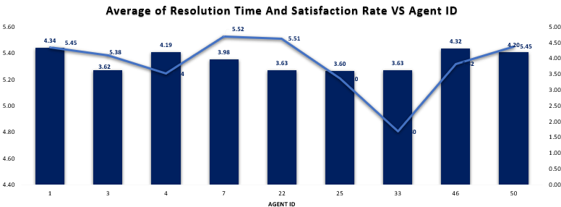

**Hiring IT Agents:** It is likely to reduce resolution times by increasing the team's capacity to handle tickets promptly. As the below line graph shows that the ticket volume keeps on increasing over the years. The variation in the handling of such tickets by limited agents can be a vital indication of hiring more agents as well as training them.

**Improving training programs:** It can enhance both satisfaction rates and resolution times. Skilled agents are better equipped to resolve issues efficiently and provide a superior customer experience. If agent-level data shows significant variance in resolution performance, targeted training can bridge these gaps. Additionally, training can address patterns identified in tickets, as seen in the "Tickets" or "Request Categories" sheets, to reduce repetitive issues.

**Upgrading Ticket Management Software:** Streamlined processes and automation can improve efficiency and reduce resolution times. Better analytics and reporting can identify trends, improving future decision-making.

The satisfaction rate and Resolution time both increases significantly with the software upgrade, showing that a more effective ticket management system benefits the entire team, leading to faster resolutions and better customer satisfaction scores.

1. **Which agents need additional training based on their performance metrics?**

**Analysis: Identify agents with the lowest satisfaction ratings and longest resolution times.**

Referring to the Analysis worksheet, after filtering the red-colored cells for Average Resolution Time (above average) and Average Satisfaction Rating (below average), we identify the following agents with below-average performance whose both average resolution time and satisfaction rate are marked red:

These agents exhibit high resolution times and low satisfaction ratings, indicating a need for additional training to improve both efficiency and customer satisfaction.

1. **Do certain categories of requests have longer resolution times? Analysis: Analyze the resolution times by request category.**

Applying Pivot and using category in Rows and Resolution Time in values as average we got below table.

* Hardware Requests have the highest average resolution time at 7.63 days.
* Login Access Requests have the shortest resolution time at 0.31 days.

**Recommendations:**

Allocate Resources to Hardware Issues: Hardware requests have the longest resolution time, and you may want to allocate more resources (technical expertise, faster procurement processes, etc.) to address these requests more efficiently.

From the analysis, it is clear that hardware-related issues take significantly longer to resolve than other categories, while login access issues are resolved almost immediately. By focusing on improving resources and processes for hardware requests, while maintaining efficiency in categories like login access, you can optimize resolution times across the board.

1. **How effective are the current software tools in managing IT tickets?**

**Analysis: Evaluate performance metrics before and after the implementation of new tools.**

To evaluate the effectiveness of the current software tools in managing IT tickets based on the provided image, we need to focus on two key performance metrics: SEVERITY of tickets and PRIORITY assigned to tickets.

**ROWS🡪**  SEVERITY OF TICKETS

**COLUMNS🡪** PRIORITY OF TICKETS

**Performance Evaluation:(CURRENT SOFTWARE)**

* From the above pivot table, we can notice that the tickets with Urgent priority are left unassigned
* And also, tickets are not being assigned based on the severity level and by considering the priority.
* The tickets were not assigned based on their severity level
* Employees had to face a lot of waiting time
* High volume of tickets was left unassigned, increasing delays and workloads

**RECOMMENDATIONS:(After implementing the new tools)**

* All tickets are tracked and managed effectively avoiding delays and ensuring no tickets are left unassigned
* Alerting the agents about the High-severity tickets to be addressed quickly
* Speed up ticket resolution times by providing ready access to solution for common issues
* Can handle increasing ticket volumes by hiring more agents and providing necessary trainings
* Timely resolutions will enhance satisfaction ratings.

1. **How has the performance of the IT support team changed over time (e.g., monthly or quarterly)?**

**Analysis: Trend analysis using time series charts**

The overall trend reflects a significant improvement in the IT support team's performance from 2016 to 2020, indicating effective enhancements in customer satisfaction efforts.

NO MAJOR FLUCTUATIONS WERE SEEN DURING 2016-2020.

PEAK SATISFACTION RATE 🡪QUARTER 2 (YEAR 2020)

1. **If we invest more on tech (Hardware, software, etc), do you think it will improve the ticket resolution times and employee satisfaction?**

**Analysis: Use historical data to project potential improvements.**

**Approach:** Used historical data to project potential improvements. For instance, compare periods when new tech tools or hardware were introduced with corresponding changes in resolution times and satisfaction. A positive correlation would justify further investment in tech.

**Average resolution time taken by request category:**

* Software - 5.24
* Hardware - 7.63

**Average satisfaction rate by request category:**

* Software - 4.1
* Hardware - 4.1

**Conclusion -** If we invest more in tech, it will surely decrease in resolution time but may not increase in satisfaction rate because as we can see above the satisfaction rate is same for almost every tech category.

So, we can invest in the tech because it will affect the key metrics like decreasing the resolution time. With decreased resolution time satisfaction rate for will also improve.

1. **What are the key performance metrics for IT agents, and how can they be improved, do we need to fire any agents?**

**Analysis: Define and analyse metrics such as average handling time, satisfaction scores, and number of tickets resolved.**

**APPROACH:**

* Key metrics to analyze the performance of IT agents include average handling time (Avg. Resolution time), satisfaction scores, and the number of tickets resolved.
* Agents with consistently poor performance (e.g., high AHT (Avg. Resolution time) and low satisfaction) should receive additional training or coaching.
* Firing agents should be a last resort, with a focus on improving performance first.

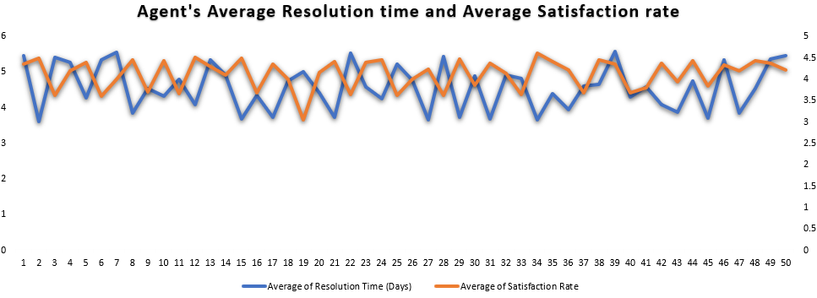

**Ticket’s handled by Agent ID:**

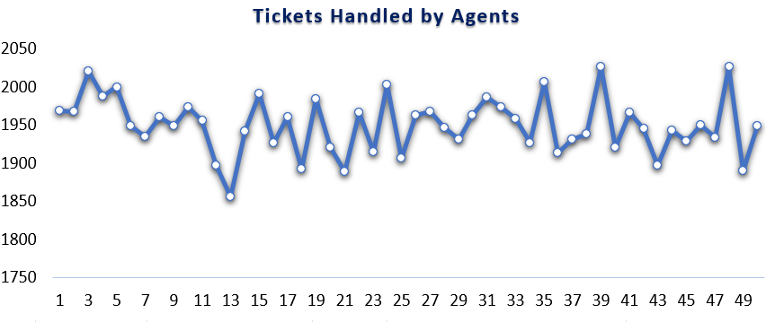

**INSIGHTS:**

* Found few agents with lower satisfaction rates and also higher resolution times
* Found few agents with high ticket count with higher resolution times
* Found few agents with low ticket count with low satisfaction rates
* Found top-performing agents with lesser resolution time and higher satisfaction rates

**RECOMMENDATIONS:**

* To the least performing agents, proper training needs to be given
* No need to fire any agents as they can be trained on specific areas in which they need to be upskilled
* Provide additional training and support tools to agents
* Ensure agents have the complete knowledge or skills required to handle the tickets
* Implement a system to follow up with any dissatisfied employees
* Provide agents with better task management and time-tracking tools to stay on track
* Add temporary resources during periods of high-ticket volume
* Set clear, measurable goals with timelines

1. **How do employee demographics (e.g., department, seniority) impact satisfaction and ticket outcomes?**

**Analysis: Segment analysis using filters and pivot tables.**

* From the dataset, it’s been observed that the average age of the employees is 39.98
* Most of the employees are aged above 35, may hold good number of experiences in the same field
* Their experience can lead to better resolution of complex issues
* They may be more patient and thorough in addressing issues, often leading to higher customer satisfaction

**ROWS🡪 SATISFACTION RATE**

**COLUMNS🡪 AGE OF AGENGTS**

**VALUES🡪 REPRESENTS THE AVERAGE SATISFACTION RATE OF AGENTS AGE WISE**

**INSIGHTS:**

* From the dataset, it’s been observed that the average age of the employees is 39.5
* Most of the employees are aged above 35, may hold good number of experiences in the same field
* Their experience can lead to better resolution of complex issues
* They may be more patient and thorough in addressing issues, often leading to higher customer satisfaction

**CONCLUSION:**

* Agents with high experience may have better skills and problem-solving abilities which can result in quicker resolutions for complex issues.
* Agents with low experience may need regular training programs to improve their skills and capabilities.

1. **Identify the trends for IT support operations based on ticket volumes and satisfaction, and mention the peak and stable times?**

**Analysis: Use pivot tables and charts to identify peak and off-peak hours**.

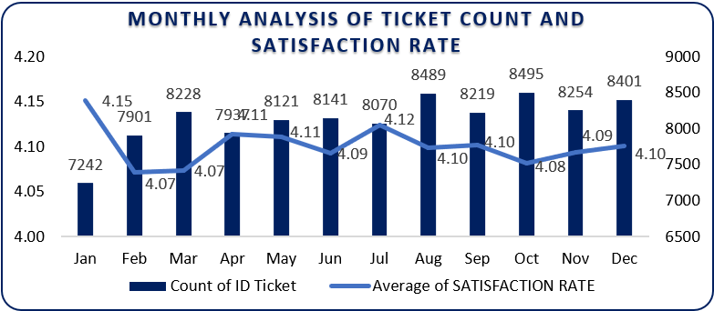

* It can be observed that the **months August, October and December** have a higher number of tickets count compared to other months
* **January** is the month will **lowest count of ticket** but with **highest satisfaction rates**
* In the months May, June and July there is not much increase in the count of tickets, depicting some sort of stability
* Lowest satisfaction rate is being recorded in the month of Feb and Mar
* Tickets volumes are high and satisfaction is dropped due to delayed responses or unassigned tickets

**SOME RECOMMENDATIONS ARE:**

* During peak time, more resources need to be allocated to reduce waiting time for tickets and provide quicker resolution
* When the ticket volume is low, agents can be given proper training to upskill their knowledge about hardware or software to handle the tickets more efficiently
* Use stable periods to perform system updates or hardware maintenance
* Continuous monitoring of ticket trends and satisfaction metrics ensures smoother operations and improved employee satisfaction

1. **What metrics should be included in the final dashboard to provide a comprehensive view of call centre performance and guide investment decisions?**

To create a comprehensive dashboard that effectively represents call center performance and informs investment decisions, consider incorporating the following metrics and visualizations:

**Key Metrics for Call Centre Dashboard:**

1) Customer Satisfaction Score Over Time

◦ Visualization: Bar Chart

◦ Description: This chart displays the trend of customer satisfaction scores over a specified period, allowing stakeholders to assess the effectiveness of service improvements and identify patterns or anomalies.

2) Average Resolution Time by Request Category

◦ Visualization: Line chart

◦ Description: This chart shows the average time taken to resolve issues categorized by request type (e.g., technical support, billing inquiries). It helps in understanding which categories require more resources or process optimization.

3) Request Category wise Ticket Count:

◦ Visualization: Bar chart

◦ Description: This chart illustrates the distribution of tickets based on their request category. It provides insights into team morale and engagement, which can impact overall performance.

4) Priority wise Ticket Count

◦ Visualization: Bar Chart

◦ Description: This chart illustrates the distribution of tickets based on their priority. It provides insights into team morale and engagement, which can impact overall performance.

5) Severity wise Ticket Count

◦ Visualization: Bar Chart

◦ Description: This chart illustrates the distribution of tickets based on their Severity. It provides insights into team morale and engagement, which can impact overall performance.

6) Agent's Average Resolution time and Average Satisfaction rate

◦ Visualization: Line chart (Combo)

◦ Description: This chart shows the average time taken to resolve issues and average satisfaction rate for each agent. It helps in understanding which agent require more training or optimization.